LinkedIn / Facebook Post Suggestions
Post #1:
We have seen an increasing number of our law firm clients standardize on Zoom as their primary meeting service but it’s often the case that they are invited by their clients to other meeting services. @SynergySKY makes it very easy to join any of those meetings direct from their Zoom Room endpoints.
Hashtag: @PartnerName #ZoomMeetings #ZoomRoom #DTEN #Logi #Yealink #Neat
Post # 2:
Switching to MS Teams or Zoom rooms is not always the answer to making it easier for users to join internal and external meetings on MS Teams, Zoom, Google, Webex, Facetime, etc. @SynergySKY CONNECT eliminates device replacement while increasing meeting room usage by enabling users to join ANY Teams, Zoom, Google, Webex, GoTo, Facetime meeting.
Hashtag: @PartnerName #ZoomMeetings #MS Teams #GoogleMeet #FaceTime #Webex #Poly #Cisco #ModernWorkplace
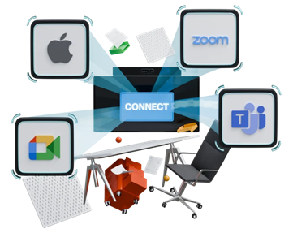
Post # 3:
Law firms are demanding clients. Time is money. Delays and confusion in joining meetings can result in a loss of billable hours and possibly damage your firm’s image. At @SynergySKY we simplify the join experience into any meeting platform from any Cisco or Poly video system.
HASHTAG: @PartnerName #ZoomMeetings #MS Teams #GoogleMeet #FaceTime #Webex #Poly #Cisco #ModernWorkplace #videoconferencing
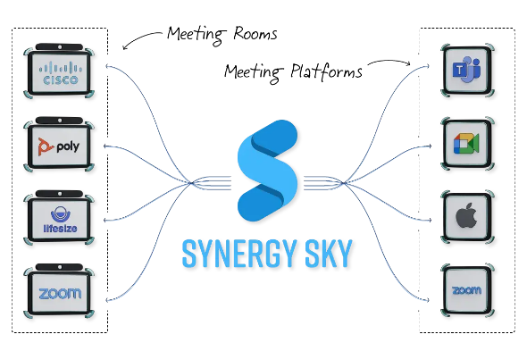

Post #4:
Why are an increasing number of law firming trusting @SynergySKY to simplify joining the meeting they need to be in from any @Cisco and @Poly video system:
- Multiple ways to join: Click to JOIN, JOIN by Meeting Code, Scan to JOIN (QR)
- Meetings start on time without the need for IT/AV support
- Feature parity which matches the experience on the desktop/mobile client
- Fast and easy content sharing via HDMI, wireless (Miracast/Airplay), or via meeting platform app
- Consistent 1080p High Definition video, audio and content
- Frictionless and stress free!
Hashtag: @PartnerName #ZoomMeetings #MS Teams #GoogleMeet #FaceTime #Webex #Poly #Cisco #ModernWorkplace #videoconferencing
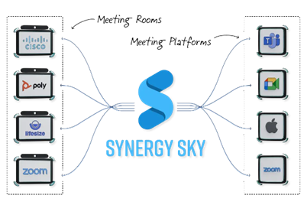
TIPS & TRICKS:
https://impactable.com/how-to-write-linkedin-posts/
https://salesbread.com/linkedin-post-examples/

